Datum: | Projekt OBOGATENO UČENJE TUJIH JEZIKOV 2013-15

Šola | Gimnazija Ptuj, Volkmerjeva cesta 15, Ptuj
Avtor 1
 | Brigita Vertič kumer | angleščina | 50 (%)
Avtor 2
 | Benjamin Tweedie | angleščina | 50 (%)

Priloga 2

- Opis priloge

Vrsta | Didaktizirano učno gradivo z refleksijo o uporabi
Datum nastanka  (d/m/l ali vsaj šolsko leto) | Marec/april 2014
Ciljna skupina  (komu je gradivo namenjeno oz. kdo ga je uporabil) | Dijaki, udeleženci modeliranja
Datum/-i uporabe  (d/m/l ali vsaj šolsko leto) | 10.4.2014

Za vrsto priloge upoštevaje opredelitve iz spodnje preglednice:

Št. | Razvojno-raziskovalno delo:  KATEGORIJE AKTIVNOSTI | Vrste izdelkov: Priloge
 | Vodenje šolskega projektnega tima (VPT) | - Načrt dela ŠPT  - Umestitev TU v ŠIK  - Načrt in evalvacija internih usposabljanj  - Poročilo o poteku in rezultatih projekta  - Študija primera
 | Koordinacija pouka tujega jezika (KTJ)
 | Izvajanje timskega pouka s tujim učiteljem | - Priprava na pouk z refleksijo oz. evalvacijo izvedbe  - Didaktizirano učno gradivo z refleksijo o uporabi  - Navodila in priporočila za učitelje
 | Izvajanje timskega pouka (slovenski učitelji - razvijanje strokovne pismenosti v TJ)
 | Izvajanje timskega pouka (slovenski učitelji - medjezikovne povezave)
 | Organizacija modeliranj timskega pouka | - Program usposabljanja z modeliranjem timskega pouka s poročilom o izvedbi
 | Izvajanje modeliranj timskega pouka | - Priprava na pouk z refleksijo oz. evalvacijo izvedbe  - Didaktizirano učno gradivo z refleksijo o uporabi  - Delavnice za udeležence

- Poročilo o uporabi: Refleksija oziroma evalvacija*
*Ne velja za naslednje priloge: Načrt dela ŠPT, Poročilo o poteku in rezultatih projekta in študijo primera.

Presoja avtorja/avtorjev (vsakega posebej, če poučujeta različne predmete oz. se razhajata v mnenjih) o uspešnosti, učinkovitosti in prenosljivosti novosti oz. razvojne rešitve (skupaj 500-750 besed)

Refleksija avtorja 1 | S tujim učiteljem sva vložila precej truda v pripravo učnih gradiv. TU je tudi glasbeni navdušenec (igra instrument), tako da je bilo delo malo lažje. Dijaki so glasbeno terminologijo spoznali že pri urah glasbe. Ekfrastična poezija pa je bil nov pojem. Najprej sva kot stimulus ponudila sliko Van Gogha, kasneje pa glasbene posnetke. Dijaki so ob poslušanju preverili znanje glasbe in terminologije tudi v angleščini. Tu so potrebovali kar nekaj pomoči SU. Kasneje so se preizkusili v pisanju ene od oblik ekfrastične poezije, kjer pa so bili zares kreativni. V končnem izdelku so pokazali znanje glasbene terminologije in angleščine.
Refleksija avtorja 2
Odzivi in menja drugih (tj. ciljne publike: učencev/dijakov, učiteljev, ravnatelja, udeležencev …) | Udeleženci modeliranja so bili navdušeni in nekateri so takoj našli ideje za navezavo na njihovo predmetno področje, saj lahko pisanje poezije povežeš s katerokoli tematiko.

Ekphrastic Poetry

Ekphrastic poetry is the conversation between two pieces of art. The writer interprets a work of visual [or aural] art and then creates a narrative in verse form that represents his or her reaction to that painting, photograph, sculpture or other artistic creation.
http://www.firkinfiction.com/11.html

Bedroom in Arles (Van Gogh, 1888)

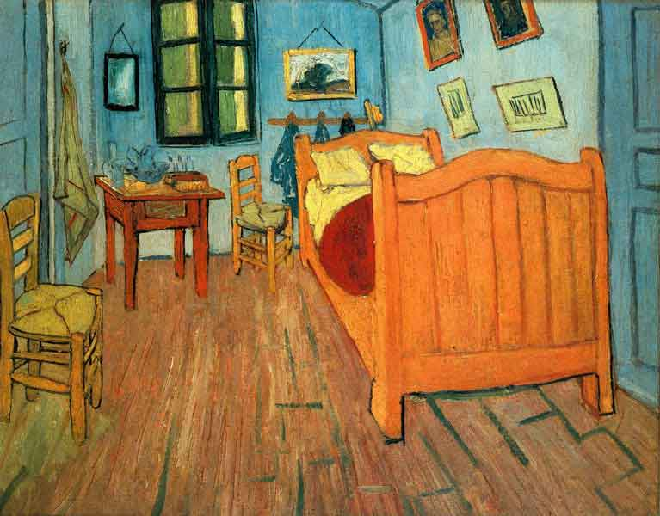
http://en.wikipedia.org/wiki/Bedroom_in_Arles

Van Gogh’s Bed (Jane Flanders, 1985)
Van Gogh‘s Bed…  is orange,  like Cinderella's coach,  like the sun when he looked  it straight in the eye.  Van Gogh‘s Bed…  is narrow.  He sleeps alone, tossing  between two pillows,  while it carried him bumpily to the ball. | Van Gogh‘s Bed…  is clumsy, but friendly.  A peasant built the frame;  and old wife beat the mattress  till it rose like meringue.  Van Gogh‘s Bed…  is empty,  morning light pours in like wine, melody, fragrance,  the memory of happiness.  http://valerie6.myweb.uga.edu/ekphrasticpoetry.html

Adapted Ekphrastic Poetry Process (for music)

- Listen to a stimulus musical excerpt and identify a music-related concept it evokes.

- If required, write down the concept, definition, law, formula etc.

- Identify a suitable poetry type and write the poem.

ACTIVITY A
(Listen to a stimulus audio excerpt and identify a music-related concept it evokes.)

Individual work

- Using thje given terminology, identify the music-related concept which corresponds with each audio excerpt (some terms may be used twice).
TERMINOLOGY

rhythm  (ritem) | tempo  (hitrost)
melody  (melodija) | dynamics  (moč)
pitch  (višina) | round  (kanon)
intonation  (intonacija) | harmony  (sozvočje)

  - Excerpt 1 – _______________________________________

  - Excerpt 2 – ______________________________________

  - Excerpt 3 – _____________________________________

  - Excerpt 4 – __________________________________

  - Excerpt 5 – __________________________________

  - Excerpt 6 – __________________________________

  - Excerpt 7 – __________________________________

  - Excerpt 8 – __________________________________

ACTIVITY B
(If required, write down the concept, definition, law, formula etc.)

Pair-work

- Match up each definition (in Slovene language) with its English-language equivalent.

DEFINITION | ENGLISH
… refers to the speed at which a piece of music is played.
… refers to the arrangement of notes according to their relative duration and relative accentuation.
… refers to the height or depth of a sound, that is, its frequency of vibrations.
… refers to the exactness of pitch or lack of it in playing or singing.
… refers to the levels of sound, loud or soft, in a piece of music.

TERM
1 | intonacija
2 | moč
3 | hitrost
4 | višina
5 | ritem

ACTIVITY C
(Identify a suitable poetry type and write the poem.)

Group-work

- The task of each group is to try and write three different poems about one of the aforementioned music-related concepts or a specific artist, band, composer or musical instrument.

FORM 1 - ACROSTIC

FORM 2 - HAIKU

FORM 3 - CINQUAIN
ACTIVITY A
(Listen to a stimulus audio excerpt and identify a music-related concept it evokes.)

- Excerpt 1 – ________pitch_________________________________

- Excerpt 2 – ________round________________________________

- Excerpt 3 – _______rhythm______________________________

- Excerpt 4 – _______harmony_________________________

- Excerpt 5 – _______intonation________________________

- Excerpt 6 – _______tempo___________________________

- Excerpt 7 – _______melody__________________________

- Excerpt 8 – _______dynamics_________________________

ACTIVITY B
(If required, write down the concept, definition, law, formula etc.)

DEFINITION | ENGLISH
… refers to the speed at which a piece of music is played. | 3
… refers to the arrangement of notes according to their relative duration and relative accentuation. | 5
… refers to the height or depth of a sound, that is, its frequency of vibrations. | 4
… refers to the exactness of pitch or lack of it in playing or singing. | 1
… refers to the levels of sound, loud or soft, in a piece of music. | 2

ACTIVITY C
(Identify a suitable poetry type and write the poem.)

FORM 1 - ACROSTIC
Music is the common language of the world
Of all the musical maestros, he stands aloof
Zealous are his tunes in melody and colour
Acquiring the attention from the listeners
Relieving all kind of grieve and anxiety
To bless his soul, listen to his music

http://www.joglab.com/acrostic-poem/?topic=Mozart

FORM 2 - HAIKU
Bad in | to | na | tion
Strings are sharp and reeds are flat
Brass, too loud a | gain

http://www.violinist.com/discussion/response.cfm?ID=5332

FORM 3 - CINQUAIN
Guitar
Lean, Mean
Strumming, Hitting, Rocking
Louder Than An earthquake
Rock’N’Roll

http://poetrywriter101.blogspot.com/2009/04/drums-guitar-microphone-cinquains.html

